

BAPTIST CHURCH

January

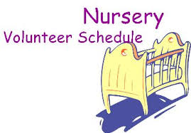
Jan 01……………….Paula Knobloch, Mickey Stanford
Jan 08…………………....Shirley Marecle, Patti Radford
Jan 15………………………..…Cissy Atwood, Becky Yount
Jan 22..Ashley Smothermon, Christine McManus
Jan 29……………………..Terri Edwards, Debby Dunkin
Jan 29…..Terri Edwards, Debby Dunkin

Weekly Service & Activity Schedule:

SUNDAY
Sunday School 9:45 a.m.
Morning Worship Services 11:00 a.m.
Evening Worship Services 6:00 p.m.

WEDNESDAY
Meal/Wednesday Bible Study. 6:30 p.m.

1662 CR 305

McDade, TX 78650

Phone: (512) 273-2743

Email: KnobbsSpringsBaptist@gmail.com



KnobbsSpringsBC.com

David Atwood – Pastor
(512) 470-5098

Patti Radford - Office Manager

KnobbsSpringsBaptist@gmail.com
512-273-2743

January Ushers
Joe Wilson, Wayne Marecle,
Jack Radford, Mickey Stanford

January Hostesses/Hosts

Christine McManus, Judy Broussard,

Evelyn Robinson, Jane Tooley
WHAT’S GOING ON?

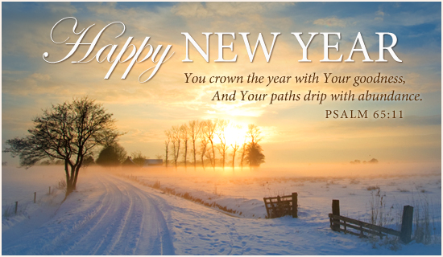

New Commandment Kids
Hands-on mission work thru puppet ministry and crafts to share with nursing homes, shut-ins, etc. Meeting the 1st and 2nd Sunday of each month @9:30 am
Ages Kinder thru 12th grade are welcome

January
1…….…………..………Happy New Year!!
1…………..……New Commandment Kids
8………………..New Commandment Kids
8………..Lord’s Supper/Business Meeting
12………………………….Adult Fellowship
12…..……….Assoc. Fish Fry - Somerville
26…………..……………..Adult Fellowship

Week of Prayer Dec 4 – Dec 11


Meeting the 2nd and 4th Thursday of each month @ 10:00 am


2nd Sunday of each month after evening worship



A new year already? They go so fast! As I write this for the Newsletter, I am wondering if you consider the new year a time to start over, or a time to continue. We, as Christians, are so blessed by our Heavenly Father. I hope you consider the new year a time to continue on; to serve God with renewed zeal and determination.
A certain family had two sons. The older said he must make a name for his family, so turned his face toward Parliament and fame. The younger decided to give his life to the service of Christ and turned his face toward China and duty. He was Hudson Taylor, the missionary, who died beloved and known on every continent. “But” someone wrote, “when I looked in the encyclopedia to see what the other son had done, I found these words, ‘the brother of Taylor Hudson’ “. It may be that some were inclined to ridicule Hudson when he went to the mission field, but in the end, he was respected and admired. His mercifulness had not been in vain, even as far as the world was concerned. But the merciful also receive recognition and reward from God, Himself. This takes place both in this world and, in its full measure, the world to come.
I pray you will dedicate yourself to the mission field this new year. Mission work begins at home, and then spreads to your church, your community, and beyond. Dedicate your life this year to continuing to serve God in whatever mission field He places you.
The new year will be filled with opportunities to serve God through the services and programs of Knobbs Springs Baptist Church. Please dedicate yourself to participation and service in and through our church family. God bless each of you this new year.

David L. Atwood

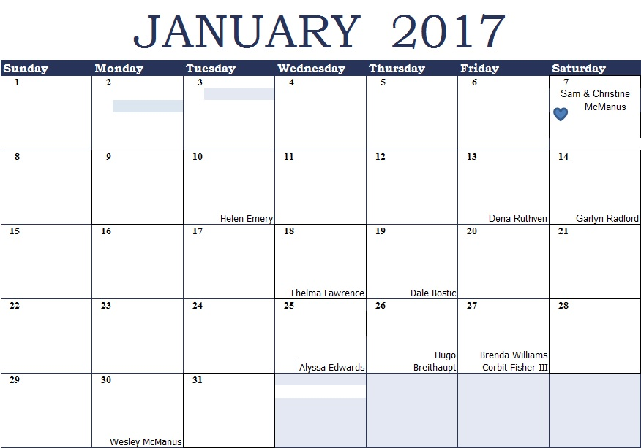
K s b c
Keeping His Word through Sunday School, Bible Study and Church Attendance/Worship
Sunday School Bible Studies for January :
Jan 1st God’s Word is Always Relevant Psalm 119:89-91 Jan 8th God’s Word is Truth Psalm 119:153-155 Jan 15th Created for a Purpose Jeremiah 1:4-5 Jan 22nd Praying with Joy Philippians 1:3-6 Jan 29th Sharing with Joy Philippians 1: 12-14

9:45 a.m. each Sunday – A place for everyone
WE’D LOVE FOR YOU TO JOIN US!

